***This is just a worksheet. Do not submit this document. Once you have completed all of the problems, copy and paste the required answers in the report template and submit it to the appropriate Dropbox.***
NOTE: The diagram displayed during the experiment is not used.
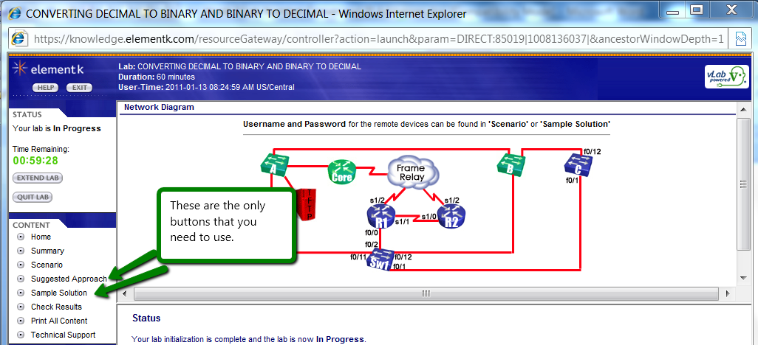
- The only buttons that you need to be concerned about are the Suggested Approach and the Sample Solution.
- Insert the correct answers into this document next to each conversion.
- When you are finished, copy and paste the requested answers in to the lab reporting document.
COMPUTING USABLE SUBNETS AND HOSTS
1) You are given the Class C network address 192.168.89.0. From this network, if you needed to create two subnets, how many bits would need to be borrowed, at a minimum?
2) Given that you have the Class C network address 192.168.89.0 and have borrowed 1 bit, what is the maximum number of hosts per subnet?
3) You are given the Class C network address 192.168.89.0. From this network, if you needed to create six subnets, how many bits would need to be borrowed at a minimum, and how many hosts could you have per subnet?
4) You are given the Class C network address 192.168.89.0. From this network, if you needed to create 12 subnets, how many bits would need to be borrowed at a minimum, and how many hosts could you have per subnet?
5) You are given the Class C network address 192.168.89.0. From this network, if you needed to create 24 subnets, how many bits would need to be borrowed at a minimum, and how many hosts could you have per subnet?
6) You are given the Class C network address 192.168.89.0. From this network, if you needed to create 40 subnets, how many bits would need to be borrowed at a minimum, and how many hosts could you have per subnet?
7) You are given the Class B network address 172.25.0.0. From this network, if you needed to create five subnets, how many bits would need to be borrowed at a minimum, and how many hosts could you have per subnet?
8) You are given the Class B network address 172.25.0.0. From this network, if you needed to create eight subnets, how many bits would need to be borrowed at a minimum, and how many hosts could you have per subnet?
9) You are given the Class B network address 172.25.0.0. From this network, if you needed to create 14 subnets, how many bits would need to be borrowed at a minimum, and how many hosts could you have per subnet?
10) You are given the Class B network address 172.25.0.0. From this network, if you needed to create 20 subnets, how many bits would need to be borrowed at a minimum, and how many hosts could you have per subnet?
11) You are given the Class B network address 172.25.0.0. From this network, if you needed to create 35 subnets, how many bits would need to be borrowed at a minimum, and how many hosts could you have per subnet?
12) You are given the Class A network address 10.0.0.0. From this network, if you needed to create 10 subnets, how many bits would need to be borrowed at a minimum, and how many hosts could you have per subnet?
13) You are given the Class A network address 10.0.0.0. From this network, if you needed to create 14 subnets, how many bits would need to be borrowed at a minimum, and how many hosts could you have per subnet?
14) You are given the Class A network address 10.0.0.0. From this network, if you needed to create 20 subnets, how many bits would need to be borrowed at a minimum, and how many hosts could you have per subnet?
15) You are given the Class A network address 10.0.0.0. From this network, if you needed to create 40 subnets, how many bits would need to be borrowed at a minimum, and how many hosts could you have per subnet?
16) You are given the Class A network address 10.0.0.0. From this network, if you needed to create 80 subnets, how many bits would need to be borrowed at a minimum, and how many hosts could you have per subnet?

CALCULATING SUBNET MASKS
1) Given a Class A network with the /20 prefix, determine the subnet mask in binary.
2) Given a Class A network with the /20 prefix, determine the subnet mask in decimal.
3) Given a Class A network with the /20 prefix, determine the maximum number of hosts it can support.
4) Given a Class A network with the /21 prefix, determine the subnet mask in binary and decimal. Then calculate the maximum number of hosts it can support.
5) Given a Class A network with the /22 prefix, determine the subnet mask in binary and decimal. Then calculate the maximum number of hosts it can support.
6) Given a Class A network with the /23 prefix, determine the subnet mask in binary and decimal. Then calculate the maximum number of hosts it can support.
7) Given a Class A network with the /24 prefix, determine the subnet mask in binary and decimal. Then calculate the maximum number of hosts it can support.
8) Given a Class A network with the /25 prefix, determine the subnet mask in binary and decimal. Then calculate the maximum number of hosts it can support.
9) Given a Class A network with the /26 prefix, determine the subnet mask in binary and decimal. Then calculate the maximum number of hosts it can support.
10) Given a Class A network with the /27 prefix, determine the subnet mask in binary and decimal. Then calculate the maximum number of hosts it can support.
11) Given a Class A network with the /28 prefix, determine the subnet mask in binary and decimal. Then calculate the maximum number of hosts it can support.
12) Given a Class A network with the /29 prefix, determine the subnet mask in binary and decimal. Then calculate the maximum number of hosts it can support.
13) Given a Class A network with the /30 prefix, determine the subnet mask in binary and decimal. Then calculate the maximum number of hosts it can support.
14) You have been assigned the 172.25.0.0 /16 network. You need to establish 12 subnets. Determine the number of bits that need to be borrowed.
15) Write out, in both binary and decimal formats, the subnet mask needed to create 12 subnets for the 172.25.0.0 network.
16) Look at your subnet mask and identify which octet contains the split between the network portion and the host portion of the address.
17) The third octet is 240 in decimal. Subtract this value from 256 to determine the size of the subnet blocks.
18) On a separate sheet of paper, write down the network IP address you started with: 172.25.0.0. Then write it three more times, each on a separate line, but leave a blank for the octet that contained the network-host split.
19) Remember when you calculated the subnet block size to be 16? Each of the 12 subnets will be in blocks of 16, starting with 0. On your paper, fill in the other three blanks in multiples of 16.
20) Create two more columns to the right of the subnet numbers you listed. For each line, determine what would be the absolutely last possible address before reaching the subnet number in the next line.
21) Take the number in the first column and add 1. Place the answer in the middle column. Subtract 1 from the number in the last column. Place the answer in the middle column, as well. These numbers represent the range of addresses you can assign to hosts for each subnet.
22) You have been assigned the 192.168.1.0 /24 network. You need to establish six subnets. Determine the number of bits that need to be borrowed.
23) Write out, in both binary and decimal formats, the subnet mask needed to create six subnets for the 192.168.1.0 network.
24) Look at your subnet mask and identify which octet contains the split between the network portion and the host portion of the address, and then subtract that number from 256 to calculate the subnet block size.
25) On a separate sheet of paper, write down the network IP address you started with: 192.168.1.0. Then write it three more times, each on a separate line, but leave a blank for the octet that contained the network-host split.
26) Your subnets are in blocks of 32. The first subnet starts with the number 0. On your paper, fill in the missing blanks in multiples of 32.
27) Create two more columns to the right of the subnet numbers you listed. In the third column, determine what would be the absolute last possible address before reaching the subnet number of the next line. Do this for each subnet.
28) Determine the range of host addresses for each subnet.
29) Your PC has been assigned the 192.168.111.129 address in a /28 network. Write out the default subnet mask and determine how many bits have been borrowed.
30) Write out, in decimal form, the subnet mask notated by /28 for the 192.168.111.0 network.
31) Look at your subnet mask and identify which octet contains the split between the network portion and the host portion of the address and subtract that number from 256 to calculate the subnet block size.
32) On a separate sheet of paper, write down the network IP address the admin started with: 192.168.111.0. Then write it three more times, each on a separate line, but leave a blank for the octet that contained the network-host split.
33) Your subnets are in blocks of 16. The first subnet starts with the number 0. On your paper, fill in the missing blanks in multiples of 16.
34) Create two more columns to the right of the subnet numbers you listed. In the third column, write in the missing directed broadcast addresses.
35) Determine the range of host addresses for each subnet.
36) Looking at the pattern of subnets you have calculated, what would be the subnet address, range, and directed broadcast address for the host 192.168.111.129?
37) This last subnetting problem is a challenge. Write out your calculations on paper, like you’ve done in previous steps. In this scenario, your PC has been assigned the 172.20.0.129 address in a /25 network. Write out the default subnet mask and determine how many bits have been borrowed.
38) Based on the subnet mask, determine the size of the subnet blocks.
39) Starting with 172.20.0.0, write out the first six subnet numbers.
40) Write out the directed broadcast addresses for the first four subnets.
41) Write out the host ranges for the first four subnets.

